PROGRAMS 2022
Local Aboriginal Land Council

MARUMALI PROGRAM | DATES | TIME | LOCATION | AGE  Group
School Holidays Health and Cultural  Learning Day  l Bush Walk  l Artefacts & Art  l Culture  l Health | TBC | 9.30 am – 4 pm | - Flintstones Cave-Heathcote Ridge  - Red Hands  - Cave-Sandy Point  Burnum Burnum Reserve-Woronora | 10 Yrs +
Walk and Yarn  A gentle walking group suitable for all ages and abilities, which offers the dual focus of physical activity and social and emotional wellbeing | Every Tuesday | 9:30am | Meet at 64 Macquarie Street for Transport to Bigge Park | Open
Women’s Group  Come together in a safe space free from judgement, and share about Women’s business. Help your spirit and body be strong with health and wellness knowledge | Every Thursday during school terms | 10 am – 1 pm | Liverpool Women’s Health, 26 Bathurst Street Liverpool | Women  18yrs +
Martial Arts Fitness and Healthy Lifestyle  Martial arts classes for school aged children, to increase social, emotional and physical wellbeing in a culturally appropriate space | Every Wednesday during school terms | 4.30 pm to  5.30 pm | 103 Moore Street, Liverpool | 8 Yrs +
Burrayi (Babies) Program  This program will connect mothers in the area to help create a supportive community while raising your children, and begin lifelong friendships | TBC  Please register interest | TBC | TBC | Pregnant mums or mums with babies/children up to 4 years

MARUMALI PROGRAM | DATES | TIME | LOCATION | AGE  Group
Cultural Education and Health Activities  Suitable for Schools & Childcare Centres | Varied based on school & age groups | Negotiable Decided by both parties | School grounds | Open  Contact us to discuss

Please contact Marumali for more information
Office:  Business address: Phone number: Email:  Facsimile number: Business hours: | Level 1, 64 Macquarie Street, Liverpool NSW 2170  P.O. Box 1038 Liverpool Business Centre, 1871 (02) 9602 9677/ 0434 692 287 marumaliadmin@glalc.org.au  (02) 8712 0561  8:00 am to 5.00 pm Monday to Friday
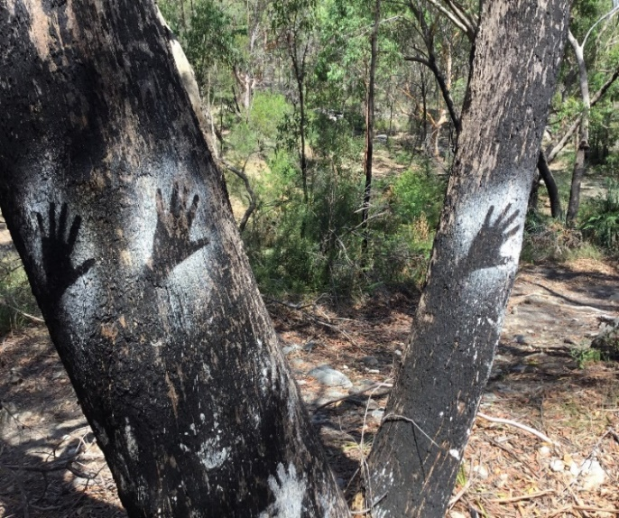
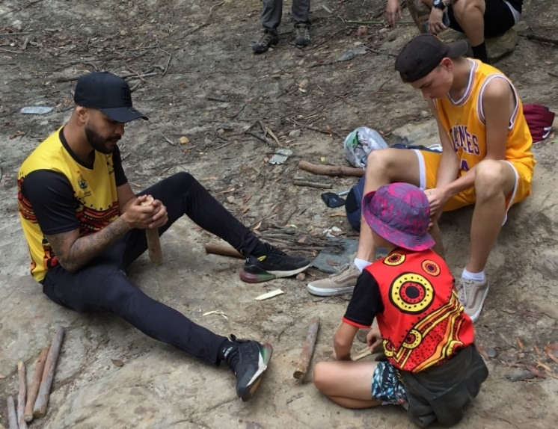
ABN 14 125 974 727  POSTAL ADDRESS:  P.O BOX 1038 LIVERPOOL BC 1871 | ACN 125 974 727  STREET ADDRESS: 1ST FLOOR  64 MACQUARIE STREET  LIVERPOOL NSW 2170

2022 PROGRAMS
Cultural Learning Day |  | Walk and Yarn
Women’s Group |  | Martial Arts Fitness and Healthy Lifestyle
Burrayi (Babies) Program |  | School Incursions
 |  | Other: ___________________

REGISTRATION INFORMATION
Name: |  |  |  | DOB:
Gender: Male / Female/ Other | Identity: Aboriginal / Torres Strait Islander / Both / Neither
Medicare: |  | IRN: | Exp:
Pension/HCC: |  | Exp:
Address:
Phone: |  | Alternate Phone:
Emergency Contact/NOK: Relationship to patient: |  | Phone:
If under 18:
Parent/Guardian Name: (if required)
Parent/Guardian Signature: (If required)
Phone (if different to NOK)

Local Aboriginal Land Council

Patient Consent Form

Marumali requires your consent to collect personal information about you for the purpose of pro- viding quality health care.

Marumali Ltd will work closely with other relevant health providers and Community agencies to coordinate the best support to meet your health needs.

Please circle the following if you consent for this information to be used by Marumali Ltd in the following ways:

I give permission for my health and personal records to be stored by Marumali Ltd and shared with other relevant health providers and Community Agencies. In other words: For Marumali to have your personal information on file | YES | NO
I give permission to use my personal information to evaluate Marumali Ltd projects.  In other words: For Marumali to count you in their project reporting | YES | NO
I give permission for any filming and photography in which I appear to be used by Marumali Ltd and Gandangara Local Aboriginal Land Council, this may in- clude newsletters, training materials, presentations, reports, brochures, posters, publications and social media.  In other words: For Marumali to take photos/videos, and use them in their re- ports, publications and on their social media | YES | NO

Signature: Date of Consent Given:

Please submit your forms in person to Gandangara Local Aboriginal Land Council Reception, or
via email to marumaliadmin@glalc.org.au and we will reach out to you to confirm.
If you have any further questions please contact Marumali on 9602 9677.

Thank you for your registered interest in Marumali Programs!

